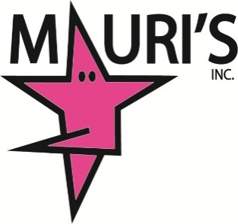
2021 - 3 Week Summer Sessions & Camps
Registration Form
Reserve Your Spot Today!

*denotes required fields

Family Information

Family Last Name*

Email Address*

Home Address*

City* State* Zip*

Primary Phone Number*

Parent/Guardian Information

Parent/Guardian Name 1

First* Last*
Email*

Mobile Number*

Parent/Guardian Name 2

First* Last*

Email*

Mobile Number*

Student Information
1. First Name* Last Name*

Birth Date* Grade Level*

Special Health Considerations*

Allergies*

Classes
Please indicate the classes you are enrolling in.
3 Week Session June 14th- 30th
Class(es):

3 Week Session July 12th - 28th
Class(es):

Camp:

Required Policies and Agreements
- Payments are due seven days prior to the start of the session. Fees are non refundable.
CHECK POLICY – Mauri’s will not be responsible for any bank fees, NSF fees, etc. A $35.00 fee will be assessed to your account for any returned checks.
LATE FEE - $10.00 late fee will be added to your bill if not paid by their due dates.

I understand and accept*

I give permission for photos of my dancer taken by Mauri’s staff in class and at performances to be used for studio advertising and social media purposes. (Mauri’s Facebook, Instagram, website and advertising pieces.)

I understand and accept*

I waive all liability of Mauri’s School of Dance, Inc. and it’s staff for injury of any type incurred while participating in studio classes or events. In case of injury, I consent to emergency medical care for my child/myself to be provided by ambulance or hospital personnel.
I acknowledge the contagious nature of COVID-19 and voluntarily assume the risk that I and/or my child(ren) may be exposed to or infected by COVID-19 by attending and that such exposure may result in personal injury, illness, permanent disability, and death. I understand the risk of becoming exposed to COVID-19 and other contagious diseases and virus may result from actions, omissions, or negligence of myself and others.

I understand and accept*

I understand that upon completion of this form, I will be billed for my tuition. I understand that upon completion of this form, I am enrolling my child in dance classes at Mauri’s School of Dance, Inc. for the 2021 summer and/or camp session.

I understand and accept*

I AGREE TO ALL OF THE ABOVE
Enter Your Full Name*

How Did You Hear About Us?*

WE LOVE WHAT WE DO…WE DANCE!

